**Assignment -1**

Python Programming

|  |  |
| --- | --- |
| Assignment Date | 19 September 2022 |
| Student Name | SAMYUKTHA V |
| Student Roll Number | 713319CS124 |
| Maximum Marks | 2 Marks |

**Question-1:**

1.Create registration page in html with username, email and phone number and by using POST method display it in next html page.

**Question-2:**

2. Develop a flask program which should contain at least 5 packages used from pypi.org

**Note:-** Following application contains (Flask , render template ,url_for, redirect, request)

So both Questions have same Answers

**Source Code:**

**App.py**

from tkinter.tix import Form

from flask import Flask ,render_template,url_for,redirect,request

app = Flask(__name__)

@app.route('/')

def index():

    return render_template("index.html")

@app.route('/success/<name>/<phone>/<email>')

def success(name=None,phone=None,email=None):

    return " <h1>Registered Successfully</h1><h2>Your Details Are:-</h2>  {} <br>{} <br> {} ".format(name , phone ,email)

    #  '{} {} {}'.format(firstname, lastname, cellphone)

@app.route("/login",methods =['POST','GET'])

def login():

    if request.method == 'POST':

        user = request.form['name']

        email = request.form['email']

        phone = request.form['phone']

        return redirect(url_for("success", name = user ,phone = phone ,email = email ))

        # name = user ,phone = phone ,email = email

    else:

        user = request.args.get("input_name")

        return redirect(url_for("success",name=user))

if __name__ == '__main__':

    app.run(debug=True)

**index.html**

<!DOCTYPE html>

<html lang="en">

<head>

    <meta charset="UTF-8">

    <meta http-equiv="X-UA-Compatible" content="IE=edge">

    <meta name="viewport" content="width=device-width, initial-scale=1.0">

    <link rel="stylesheet" href="/Assignments/Ramyadevi RS (Team Lead)/Assaignment -1/SRC/static/style.css">

    <link rel="stylesheet" href="https://cdn.jsdelivr.net/npm/bootstrap@5.2.0/dist/css/bootstrap.min.css"

        integrity="sha384-gH2yIJqKdNHPEq0n4Mqa/HGKIhSkIHeL5AyhkYV8i59U5AR6csBvApHHNl/vI1Bx" crossorigin="anonymous">

    <title>Registration page </title>

</head>

<body>

    <form method="post" action="login">

        <h2>REGISTRATION PAGE</h2>

        <div class="mb-3">

            <!---- <label for="name" class="form-label">Enter the name</label> --->

            <input type="text" class="form-control" id="name " name="name" placeholder="NAME">

        </div>

        <div class="mb-3">

            <!----<label for="exampleInputEmail1" class="form-label">Email address</label> --->

            <input type="email" class="form-control" name="email" id="exampleInputEmail1" placeholder="EMAIL">

        </div>

        <div class="mb-3">

            <!---- <label for="phone" class="form-label">Enter the phone number</label> --->

            <input type="text" class="form-control" name="phone" id="phone" placeholder="PHONE NUMEBER">

        </div>

        <button type="submit" class="btn btn-primary">Submit</button>

    </form>

</body>

</html>

**Style.css**

body{

    background-image: url("https://images.pexels.com/photos/1509534/pexels-photo-1509534.jpeg?auto=compress&cs=tinysrgb&w=1260&h=750&dpr=1") !important;

   /* background-color: rgb(255, 0, 162) !important; */

   background-position: center;

   background-repeat: no-repeat;

   background-size: cover;

    display: flex;

    flex-direction: column;

    align-items: center;

    justify-content: center;

}

form{

    display: flex;

    flex-direction: column;

    align-items: center;

    justify-content: center;

    background-color:#AFEEEE;

    width: 40%;

    height: 400px;

    border-radius: 10px;

    margin: 100px;

}

h2{

    font-size: large;

    font-weight:bolder;

}

input{

    width: 80% !important;

}

div{

    display: flex;

    align-items: center;

    justify-content: center;

    flex-direction: column;

    width: 90%;

}

**Output:**

**Index Page:**

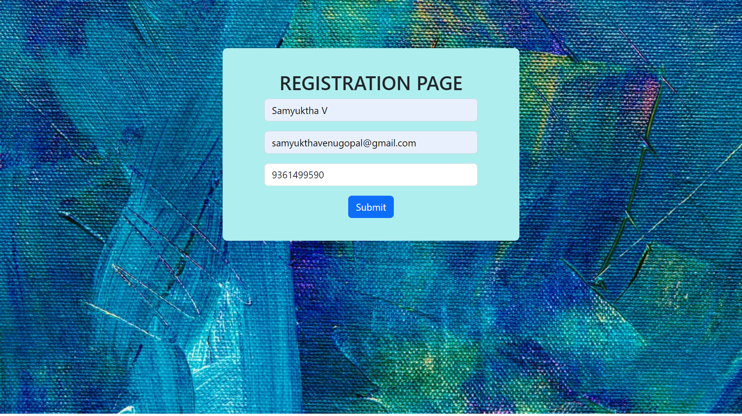

**Login successful page:**

Samyuktha V

9361499590

samyukthavenugopal@gmail.com

